## CH 3 Lesson (1)

1. The study of soil is a branch of environmental and agricultural sciences that focuses on:
   1. understanding the properties of soil C. the composition of the soil
   2. the soil effect on plants, animals and environment D. All the previous
2. Most organisms depend on for their existence.

A. Soil B. Oceans C. Rivers D. Seas

1. Soils are formed………….., but very ……….

|  |  |  |
| --- | --- | --- |
| A | Continuously | slowly |
| B | Continuously | rapidly |
| C | Discontinuously | slowly |
| D | Discontinuously | rapidly |

1. Weathering occurs as a result of processes
   1. physical only B. chemical only

C. biological only D. physical, chemical, or biological

1. Weathering processes lead to the of rocks
   1. fragmentation only C. decomposition only
   2. fragmentation and decomposition D. stability
2. are the largest component of soil

A. Minerals B. Organic matter C. Water D. Gases

1. primary minerals in the soil are the result of the fragmentation of rocks by factors.

A. physical only B. biological only C. chemical and biological D. chemical and physical

1. Most of the soil minerals are minerals.

A. Phosphate B. silicate C. acetate D. sulphate

1. The most important source of is fertilizers and plant crop residues

A. Water B. Gases C. Minerals D. Organic matter

1. The ability of the soil to retain water varies depending on:
   1. the size of the soil grains only C. the temperature only
   2. the size of the soil grains and temperature D. None of these
2. The ability of clay soils to retain water is That of sandy soils.

A. more than B. less than C. equal to D. Less than or equal to

1. **Soils that are characterized by their ability to hold water, but are poorly aerated are:**

Ⓐ **clay soils** Ⓑ**calcareous soils** Ⓒ **sandy soils** Ⓓ **loamy soils**

1. **Which type of soil contains uniformly sized sediments, making it a poor water holding soil?**

Ⓐ **clay soils** Ⓑ **sandy soils** Ⓒ **Humic soils** Ⓓ **Alluvial soils**

1. **Which soil zone contains the greatest amount of humus?**

Ⓐ **Soil surface** Ⓑ **Subsoil surface** Ⓒ **Disintegrated rock** Ⓓ **Bedrock**

# Essay

1] Explain: Most organisms depend on soil for their existence.

……..…………………………………………………………………………………………………… 2] What is meant by: The soil?

………..……………………………………………………………………………………………………

3] How is the soil formed?

……………………………………………………………………………………………………………. 4] Identify the type of weathering for each of the following processes:-

1. the fragmentation of rocks due to the temperature changes and repeated freezing and thawing of water in rocks.
2. the fragmentation of rocks due to cracks or mechanical processes when rocks rub against each other during transportation by wind and water currents.
3. the fragmentation of rocks due to falling it under the effect of Earth’s gravitational force.
4. the fragmentation of rocks due to the decomposition of the mineral components of rocks in the presence of water through a change in their chemical composition.
5. the fragmentation of rocks due to the reaction of rock’s minerals with air or other chemicals.
6. the breakdown of rocks by living organisms.
7. the breakdown of rocks by animals that dig rocks help water and air enter the rock.
8. the breakdown of rocks by growing plant roots into cracks in the rock.

5] What are the main four components of the soil?

……………………………………………………………………………………………………………. 6] Compare between the primary minerals and the secondary minerals of the soil:

|  |  |  |
| --- | --- | --- |
| **P.O.C** | **The primary minerals** | **The secondary minerals** |
| **How is**  **formed?** |  |  |
| **Its properties** |  |  |

1. Complete the figure that shows the soil components W, X, Y, and

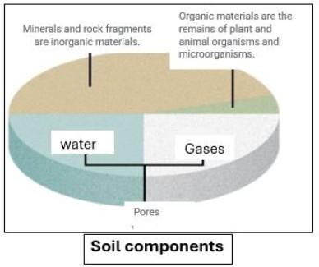

W

Z

Y

X

1. Explain:

**Water is considered an essential and important part of soil components,**

1. What are the factors on which the ability of the soil to retain water depends on? 10] Explain:

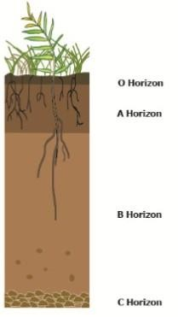

**Clay soils are better at retaining water than sandy soils.**

11]The figure shows the soil profile:

Write the horizon (zone) that will be identified by each of the following statements.

1. It Consists mainly of plant remains that have accumulated on the soil surface and is rich in humus.
2. It is usually darker in color than the other horizons due to organic matter.
3. Clay-rich soil, that is often less fertile, retains more moisture
4. It is usually lighter in color, has a coarser texture, and has less biological activity.
5. It consists of cohesive or loosened rocky material.
6. Roots do not penetrate this layer.
7. The soil compaction leads to:

## Lesson (2)

1. the formation of hard, petrified layers beneath the soil surface
2. reducing the soil ability to absorb water and air
3. the soil hinders the growth of plant roots and leads to poor agricultural yields
4. All the previous
5. Which of the following practices leads to the soil compaction?
   1. The use of heavy agricultural machinery in agricultural areas excessively
   2. Groundwater containing salts is transported to the soil surface by capillary action
   3. The repeated irrigation of the soil over time
   4. Flood irrigation of the soil
6. All the following practices leads to the increase in the soil salination **EXCEPT**
   1. The use of heavy agricultural machinery in agricultural areas excessively
   2. Groundwater containing salts is transported to the soil surface by capillary action
   3. The repeated irrigation of the soil over time
   4. Flood irrigation of the soil
7. One of the biggest mistakes in agriculture is aiming to grow a single crop on the same soil and repeat this for years in a row is
   1. soil compaction
8. increase in the soil salination

C. increase in the soil efficiency and its firtility

D. causes the soil to be exhausted and lack some of the nutrients necessary for the plant to grow

1. High levels of lead and mercury in the soil has a toxic effect for:

A. plants only B. animals only C. human only D. plants, animals and human

1. In agricultural areas that rely heavily on manufactured nitrogen fertilizers to increase crop yields, excessive contamination of the soil is observed

A. Nitrate B. iodine C. lead D. mercury

1. The figure shows a baby of Blue Baby Syndrome, as a result of drinking…….-contaminated water.

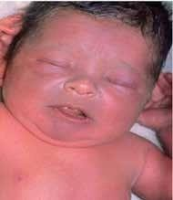A. mercury B. lead C. nitrate D. chlorine

1. All the following from the ways of soil conservation **EXCEPT**
   1. Sustainable agricultural practices
2. Using crop rotation techniques

C. Use the “no-till farming” technique

D. Growing the same crop in the same soil for several consecutive times

1. All the following are sustainable agricultural practices **EXCEPT**
   1. organic farming C. use of natural fertilizers
   2. use of biopesticides D. use the “till farming” technique
2. **The use of petrochemical compounds to kill insects leads to:**

Ⓐ Blue Baby Syndrome Ⓑ liver cancer

Ⓒ accumulation of salts in the soil Ⓓ increase of heavy metals in the soil

1. **Growing a tomato crop in the same soil for several consecutive years leads to**

Ⓐ impede the absorption of nutrients by the plants Ⓑ soil compaction

Ⓒ lack of nutrients in the soil Ⓓ increase the soil salinity

# Essay

### Q1: Give Reason

1. **plants grown in compacted soil have difficulty obtaining water and nutrients**
2. **plants grown in compacted soil have unhealthy growth.**
3. **plants grown in compacted soil have poor crop yields**
4. **The salinity of the soil increases due to flood irrigation**

**The salinity of the soil increases due to repeated irrigation of the soil over time**

1. **Use the “no-till farming” technique.**

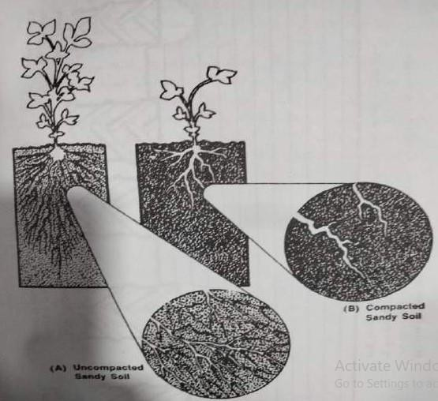

Sample X

Sample Y

Q2: The figure shows two different of soil Samples, one of them is a compacted soil and the other is not.

Which sample is the compacted one? Explain

4

Q3: What are the consequences of the following phenomenon or practices?

|  |  |
| --- | --- |
| **The phenomenon / practices** |  |
| **1) The soil compaction** |  |
| 1. Flood irrigation of the soil 2. The repeated irrigation of the soil over time 3. Groundwater containing salts is transported to the soil surface by capillary action |  |
| 5) The industrial waste drainage |  |
| 6) contamination of agricultural soil with “gasoline” liquid in areas surrounding oil refineries |  |

**Q4: Explain how industrial activities can negatively affect soil quality. Provide a practical example to support your answer.**

**Q5: Why is the excessive use of pesticides and chemical fertilizers harmful to the soil? How can we reduce this negative impact?**

**Q6: Suggest one agricultural practice that can be used to protect the soil from Degradation Q7: Show two from the ways of soil conservation.**

## Lesson (3)

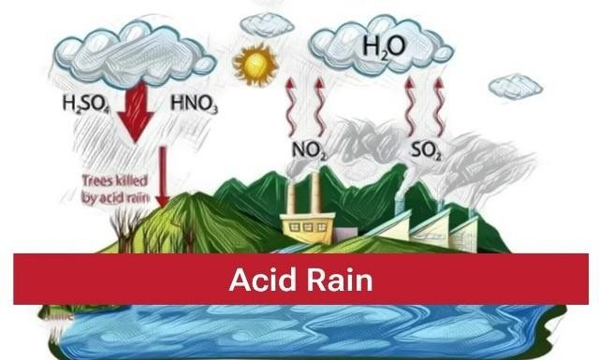

Q1: Choose the correct answer

1. The soil compaction leads to:
   1. Alkaline rain C. Acid rain
   2. Conventional rain D. Cyclonic rain
2. Which of the following compounds causes acid rain?
   1. Sulfur oxides and nitrogen oxides C. Aluminum oxides and calcium oxides
   2. Sodium oxides and copper oxides D. Lead oxides and magnesium oxides
3. All the following from the consequences of the falling of acid rain on the soil **EXCEPT**
   1. eroding essential minerals in the soil D. decreasing the level of aluminum in the soil
   2. decreasing the level of calcium and magnesium in the soil
   3. reducing soil fertility
4. Acid rain stimulates the deposition of toxic metals like in the soil.

A. Calcium B. magnesium C. phosphorus D. aluminum

1. What is the primary cause of acid rain?
   1. Evaporation of water from oceans C. Reaction of sulfur dioxide with water vapor
   2. Air pollution by plastic pollutants D. Accumulation of dust in the atmosphere
2. What is the effect of acid rain on plant soil?
   1. Increased soil fertility B. Improved soil structure and enhanced plant growth
3. Improved soil quality and increased nutrients
4. Erosion of essential minerals in the soil and release of toxic metals
5. Which of the following is a direct effect of acid rain on agricultural crops?
   1. Increasing agricultural yield D. Reducing crop quality and productivity
   2. Enhancing healthy growth of crops
   3. Improving crop stability under changing environmental conditions
6. Which of the following measures is preferred to address the effects of acid rain on soil?
   1. Adding large amounts of chemical fertilizers C. Using lime fertilizers to neutralize acids
   2. Increasing the use of pesticides D. Removing contaminated soil and discarding it
7. Soil humidity is the total amount of found in the soil’s fine pores or on its surface.

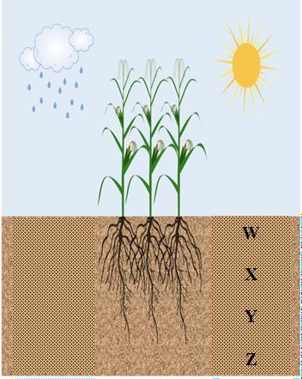A. Water B. air C. oxygen D. nitrogen

1. **At which depth beneath the soil surface, the soil humidity is greatest?**

A. W B. X C. Y D. Z

1. **A soil sample of dry mass 842.8 kg and moist mass 931.3 kg. then the percent of its humidity equals ………**

A. 9.5 % B. 10.5 % C. 11.5 % D. 12.5 %

1. Element in the soil is essential for healthy growth of plant and flower

formation.

* 1. Nitrogen (N) B. Phosphorus (P) C. Potassium (K) D. Aluminum (Al)

1. Element in the soil helps strengthen plant roots.
   1. Nitrogen (N) B. Phosphorus (P) C. Potassium (K) D. Aluminum (Al)
2. Element in the soil is essential for the greening of plant leaves.
   1. Nitrogen B. Phosphorus (P) C. Potassium (K) D. Aluminum (Al)

### Q2: Give Reason

* + 1. **A soil erosion and changes in its chemical composition occur at falling acid rain on the soil**
    2. **The fertility of the soil is reduced at falling acid rain on it.**
    3. **Acid rain can negatively impact plant health**
    4. **Using alkaline fertilizers contributes in reducing the effects of acid rain on plants and soil.**
    5. **The increased humidity in the soil leads to the rot and death of its roots.**

**Q3: Write two of the practices for reducing the effects of acid rain on plants and soil Q4: Write two from the factors that affect the soil humidity.**

**Q5: What is the effect of each of the following on the soil humidity?**

1. **increasing the salinity of the soil**
2. **increasing the size of the soil particles**
3. **Forming a soil of consistency of particles size of mixture of clay, sand and silt.**
4. **increasing the temperature of the soil**
5. **increasing the depth inside the soil**

**Q6: What would happen at increasing the soil humidity? Explain your answer**

**Q7: A soil sample of dry mass 623.9 kg and moist mass 711.2 kg. Calculate the percent of its humidity.**

7

## CH 4 Lesson (1)

1. Using natural resources in a way that enables current generations to meet their needs without affecting the ability of future generations to meet their needs is:

A. Sustainability B. ecological balance C. biodiversity D. protecting ecosystems

1. Preserving resources and the environment for future generations include
   1. preserving biodiversity C. minimizing the use of non-renewable resources
   2. protecting ecosystems D. All the previous

.3) is the foundation of an ecosystem and its health.

1. Deforestation C. increasing the use of fossils fuel
2. preserving biodiversity D. increasing the use of non-renewable resources
3. Using is an example of resource sustainability

A. solar energy B. coal C. fossils fuel D. non-renewable energy

1. deforestation leads to …………..
   1. the loss of natural habitats for millions of animal and plant species C. the loss of biodiversity
   2. changes in local and global climate D. All the previous
2. is the process of turning fertile land into barren land

A. Pollution B. Desertification C. Deforestation D. Global warming

1. **What is the concept of sustainable development?**

Ⓐ **Meeting the needs of current generations without considering the needs of future generations**

Ⓑ **Excessive use of resources without regarding the environmental impacts**

Ⓒ **Meeting the needs of current generations without compromising the ability of future generations to meet their needs**

Ⓓ **Achieving rapid economic growth without regard to environmental consequences**

1. **What is the main objective of developing and utilizing renewable energy sources?**

Ⓐ **Increasing daily energy consumption**

Ⓑ **Reduce dependence on fossil fuels and minimize the effects of climate change**

Ⓒ **Enhance greenhouse gas emissions**

Ⓓ **Improving the quality of fossil fuels**

1. **Which of the following is considered a sustainable practice in agriculture**

Ⓐ **Using fertilizers and pesticides in large quantities**

Ⓑ **Growing the same crop in the same soil every season**

Ⓒ **Using organic farming techniques and crop rotation**

Ⓓ **Deforestation to expand agricultural land**

1. **What is the goal of environmental protection within the concept of sustainable development?**

Ⓐ **Stopping all human activities**

Ⓑ **Preserving and protecting ecosystems to ensure the continuity and balance of life**

Ⓒ **Increase environmental pollution to accelerate economic growth**

Ⓓ **Reducing green spaces and increasing urbanization**

1. **What is a common result of pollution in water bodies?**
   1. Increased fish populations B) Improved aquatic habitats

C) Harm to aquatic life and human health D) Enhanced water quality

1. **Which of the following is a renewable energy source?**
   1. Coal B) Natural gas

C) Solar energy D) Oil

1. **What is one way to promote social justice in sustainability?**
   1. Ensuring resource distribution is fair C. Prioritizing industrial growth over community needs
   2. Ignoring the needs of marginalized communities D. Increasing pollution in urban areas
2. **What is the primary goal of sustainability?**
3. **To maximize resource extraction**
4. **To meet present needs without compromising future generations**
5. **To increase industrial production**
6. **To promote urbanization**
7. **Which of the following is NOT a benefit of environmental sustainability?**
8. **Protecting biodiversity C. Improving air and water quality**
9. **Depleting natural resources D. Combating climate change**
10. **How do human activities contribute to climate change?**
    1. **By increasing biodiversity C. By conserving water resources**
    2. **By burning fossil fuels and deforestation D. By promoting renewable energy**
11. **What is a significant consequence of deforestation?**
    1. **Increased soil fertility C. Loss of animal and plant habitats**
    2. **Improved air quality D. Enhanced agricultural productivity**
12. **Which practice can help conserve natural resources?**
    1. **Overfishing C. Recycling materials**
    2. **Increasing fossil fuel usage D. Urban sprawl**
13. **What is the impact of excessive water use in agriculture?**
    1. **Improvement in soil fertility C. Depletion of water resources**
    2. **Increased biodiversity D. Enhanced food security**

### Q2: Give Reason

* + 1. **The importance of sustainability and preserving the environment for future generations**
    2. **Sustainability also supports the concept of social justice**
    3. **Deforestation is one of non-sustainable practices**

### Q3: Write two of The importance of sustainability and preserving the environment for future generations

**Q4: Explain:**

**“ Sustainability is not only about conserving resources, but also about improving the quality of life”**

* + - 1. What are chemical pollutants?

# Lesson (2)

1. **Natural substances beneficial to health**
2. **Toxic substances that can cause environmental damage**
3. **Only gases released by vehicles**
4. **Non-toxic organic materials**
   * + 1. Which of the following is a heavy metal that can accumulate in living organisms?
          1. **Carbon B) Sodium C) Mercury D) Oxygen**
       2. What is an example of water pollution caused by agricultural practices?
          1. **Heavy metals from mining C) Pesticides leaking into waterways**
          2. **Airborne particulate matter D) Industrial waste in the ocean**
       3. What is the purpose of using activated carbon in water treatment?
5. **To increase water temperature C) To absorb organic materials and pollutants**
6. **To add minerals to the water D) To filter out bacteria only**
   * + 1. Which pollutants are often measured in air analysis by using UV spectroscopy?
7. **Phosphates and nitrates C) Nitrogen oxides and ozone**
8. **Lead and cadmium D) Organic matter and chlorine**
   * + 1. Which of the following is a method for recycling chemical wastes?
9. **Disposing of it in landfills C) Burning it without treatment**
10. **Collecting and reusing it or converting it into new products D) Dumping it into water bodies**
    * + 1. All the following from the chemical pollutants EXCEPT…..

**A)Pesticides B) Heavy metals C) Volatile organic compounds D) Bacterial contaminant**

* + - 1. Which of the following is a pesticide that is used to control insects and the diseases they cause?

**A)Formaldehyde B) Lead C) Chlordane D) Chloroform**

* + - 1. Which of the following can be separated and analyzed by Chromatography?

**A)Pesticides B) Ozone C) Heavy metals D) Nitrogen oxides**

* + - 1. In drinking water treatment plants, can be used to remove

chemicals such as benzene and chloroform from the water.

1. **Ozone C) activated carbon**
2. **biological treatment by bacteria D) biological treatment by fungi**
   * + 1. **What is the main effect of lead exposure on human health?**

Ⓐ **Increased physical ability** Ⓑ **Development of nervous system issues**

Ⓒ **Improved bone health** Ⓓ **Reduced cancer incidence**

* + - 1. **What is the most common purpose for using activated carbon in water treatment?**

Ⓐ **Neutralizing acids** Ⓑ **Removing organic matter and chemical contaminants**

Ⓒ **Adding nutrient minerals** Ⓓ **Sterilizing water using ultraviolet light**

* + - 1. **What is the main source of phosphate that can cause water pollution in agricultural areas?**

Ⓐ **Organic solvents** Ⓑ **Pesticides**

Ⓒ **Agricultural fertilizers** Ⓓ **Industrial waste**

* + - 1. **What health issue can result from inhaling air polluted with particulate matter?**
         1. **Improved lung function C) Respiratory diseases like asthma**
         2. **Enhanced immune response D) Decreased heart rate**
      2. **Which analysis technique is commonly used to measure heavy metals as mercury in water?**
         1. **Chromatography C) Ultraviolet spectroscopy**
         2. **Atomic absorption spectroscopy D) Gas chromatography**
      3. **What is a potential effect of exposure to benzene?**
         1. **Decreased risk of respiratory diseases C) Increased risk of cancer**
         2. **Improved cognitive function D) Enhanced bone density**
      4. **What is biological treatment in the context of waste management?**
         1. **Using chemicals to treat pollutants C) Utilizing microorganisms to break down pollutants**
         2. **Burning waste materials D) Separating waste into recyclable and non-recyclable**
      5. **All the following are heavy metals which accumulate in the environment and in the cells of living organisms EXCEPT ……**
         1. **Lead B) Mercury C) Cadmium D) Benzene**
      6. **The accumulation of heavy metals such as lead and mercury in the soil as a result of industrial waste ……….**
         1. **increases the crops yield C) increases the photosynthesis**
         2. 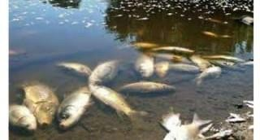**increases the soil fertility D) can affect plant growth Q2: Analyze the corresponding figure, and then answer the**

**following questions:**

1. **Write down one of the pollutants that caused the death of fish and other aquatic organisms**
2. **Explain a way to treat this environmental pollution**

### Q3: Give Reason

* 1. **Mercury is one of the dangerous chemical pollutants**
  2. **Using pesticides must be prevented**
  3. **Ozone can be used to wastewater treatment**
  4. **Activated carbon can be used in drinking water treatment**
  5. **Some types of bacteria or fungi in water treatment**